

E- Project Report

**ONLINE INSURANCE**

**ACCP 2.0 (Batch: NK_2202G1)**

*Project Instructor*

**Sir Muhammad Muneeb Ullah Khan**

Submitted by:

**Abdullah Student1359157**

**Adeen Ahmed khan Student1355497**

**Muhammad Faiq Haider Student1357930**

**Mohsin Hassan Khan Student** **1368471**

**Declaration**

*I hear by declare that the following documented project report titled ”Online Insurance” is an authentic work done by us.*

*The project was undertaken as a park of the course curriculum of E-Project, Aptech NK. This has not been submitted to any other examination body earlier.*

*CERTIFICATE*

**This is to certify that**

**Abdullah Student1359157**

**Adeen Ahmed khan Student1355497**

**Muhammad Faiq Haider Student1357940**

**Mohsin Hassan Khan Student** **1368471**

Has Successfully Designed & Developed:

*“Online Insurance Website”*

*Abdullah*

*Adeen Ahmed Khan*

*Muhammad Faiq Haider*

*Mohsin Hassan Khan*

Date of issue:

**24-08-2023**

**Preface**

Insurance is a contract for payment of a sum of money to the person assured on the happening of the event insured against. Usually the contract provides for the payment of an amount on the date of maturity or at specified dates at periodic intervals or at unfortunate death, if it occurs earlier. Among other things, the contract also provides for the payment of premium periodically to the Corporation by the assured. Insurance is universally acknowledged to be an institution which eliminates `risk', substituting certainty for uncertainty and comes to the timely aid of the family in the unfortunate event of death of the breadwinner.

Acknowledgment

First of all, we thank Almighty Allah who gives us the strength and ability to think, work and deliver what we are assigned to do.

We earnestly hope that this project will provide all the necessarily information required for the user to fulfill their inspiration. However, suggestions for improvement of the project will be thankful received & acknowledge.

**SYNOPSIS**

**ONLINE INSURANCE :-**

Insurance is a contract for payment of a sum of money to the person assured on the happening of the event insured against. Usually the contract provides for the payment of an amount on the date of maturity or at specified dates at periodic intervals or at unfortunate death, if it occurs earlier. Among other things, the contract also provides for the payment of premium periodically to the Corporation by the assured. Insurance is universally acknowledged to be an institution which eliminates `risk', substituting certainty for uncertainty and comes to the timely aid of the family in the unfortunate event of death of the breadwinner.

**Contents**

**Chapter 1 Introduction 06**

* Goals and objectives 06
* System Statement of scope 06
* Theoretical background 06
* Windows 10 07
* Visual Studio 2022 07
* HTML 5 & CSS3 07
* SQL SERVER MANAGEMENT STUDIO (SSMS) 08

**Chapter 2 Problem Statement 09, 10**

2.1 Requirement Specification 10, 11

2.2 Hardware / Software Requirements 11

**Chapter 3 System Estimates & Actual Outcome 12**

* Estimation Techniques applied 12
* System Estimate & actual outcome 12
* Estimation of Time for the Project 13
* Actual Time for the Project 13
* Actual Results 14
* System resources 14
* System Resources Used 14
* **Chapter 4 Conclusion 15**

Conclusion\summary 15

4.2 List of Validation 15

**J. APPENDICES**

* Project Schedule
* Snap Shots of Project

**CHAPTER 01**

**INTRODUCTION**

* **Introduction**

We are the best website that provide to easy product testing system for the customer those can’t wait and stand in a long queues and have no time to wait. So this website can help them to fulfil their demands and get some good results.

* **Goals and objectives**

Our CEO Goals Is to provide our customers comfort. Our website very useful for those customers who are not interested to waste her time to stand in a long queue.

* **System statement of scope**

A description of the entire system is presented. Major inputs, processing functionality and outputs are described without regard to implementation detail. System is represented as black box

* **Theoretical Background**

As you can see, Windows 10 pro is much more similar to older versions than it is to Windows 8. It's also faster and more secure

* **Technology & Tools/hardware components**

**1.4.1 Windows 10**

Windows 10 may very well be Microsoft’s most powerful platform ever made for organizations and their employees. Windows 10 is more familiar from a user experience standpoint. Still, it also includes so much of what businesses need—including enterprise-grade security, identity, and information protection features, which reduces complexity and proves a better experience for the business's modern needs.

**1.4.2 Visual Studio 2022**

**Visual Studio** is an integrated development environment (IDE) created by Microsoft for software development, coding, testing, and debugging purposes. It provides a comprehensive suite of tools and features that assist developers in building various types of applications, including desktop, web, mobile, and cloud-based applications. Visual Studio supports multiple programming languages such as C#, C++, Python, and more, offering features like code editing, project management, version control integration, and a rich set of debugging and profiling tools to enhance the development workflow.

**1.4.3 HTML5& CSS3**

Preliminary support is added for HTML5 to the HTML editor so that you can obtain Intelligence and validation for HTML elements and attributes. A complete version that brings a fuller HTML5 experience will be provided in a future version of visual studio

**1.4.3 SQL SERVER MANAGEMENT STUDIO (SSMS)**

**SQL Server Management Studio (SSMS)** is a software application developed by Microsoft for managing and working with SQL Server databases. It offers a graphical interface for tasks like querying databases, designing schemas, importing/exporting data, and monitoring performance. It's a vital tool for database administrators, developers, and analysts working with SQL Server

**CHAPTER 02**

**PROBLEM STATEMENT**

* **Problem Statement**

The Objective of this program is to give a sample project to work on real life projects. These applications help you build a larger more robust application. The objective is not to teach you the software’s but to provide you with a real life Scenario and help you create basic applications using the tools. You can revise the topics before you start with the project. These programs should be done in the Lab sessions with assistance of the faculty if required. It is very essential that a student has a clear understanding of the subject.

Kindly get back to eprojects Team in case of any doubts regarding the application or its objectives.

**Requirement Specification:**

* **This software provides four types of Insurance services, which includes**

**Life Insurance, medical Insurance, Motor Insurance. Home Insurance,**

* **Presently this project follows Internet mode i.e. the details can be viewed and updated by the officials of the company.**

**Online Insurance Service has the following features:-**

**1). A User can view the details of various policies and schemes offered By the Insurance Company.**

**2).New Users can register with the site so that he can get information Online.**

**3).An existing policyholder can view his policy details and calculate the Premium.**

**4).The web site provides information about the new strategies and Subsidiary schemes of the company.**

**5).Provides loan facility for policyholders and online payments. Calculation of the premium is to be done Term plan taken by the person.**

**Insurance includes**

Insurance-services

**Life Insurance:** Life insurance is a plan which provides protection to the insured and his family with financial coverage in case of any mishaps. To avail the benefits of life insurance policy, the policy holder has to pay a monthly premium to the insurer for a certain period of time.

**Medical Insurance:** Under this type of health care cover, medical expenses are covered. When an insured person needs medical treatment due to illness or accident, the insurance agent provides coverage for his expenses such as doctor fees, hospital fees, medicine cost and other related bills.

**Motor insurance:** Under this type of plan which provides protection against the auto-mobile the user owns.

**Home Insurance:** The most popular among the 6 types of insurance is the home insurance that provides compensation for any mishaps that occurs on your home. Coverage is provided according to the policy and premium paid by the homeowner. There are various types of home insurance plans that you can choose from to suit your needs.

**Hardware/ Software Requirements**

**Hardware**

* A minimum computer system that will help you access all the tools in the courses is a Pentium 166 or better
* 128 Megabytes of RAM or better

**Software**

* Visual Studio .Net / ASP
* IIS server
* .Net Framework
* Java Virtual Machine/ J2EE server
* Notepad/Java editor
* j2sdk1.4.1_02 (or later).
* EJB Dev. Kit
* Java enabled web server
* JSP / Servlets Dev. Kit

**CHAPTER 03**

**SYSTEM ESTIMATES & ACTUAL OUTCOME**

* **System Estimates and Actual Outcome**

Sometimes the software estimation becomes a huge below by mean of system decomposition and system resizing. System estimation and actual outcome shows your scope efforts, engineering efforts and deploy effort.

To estimate time and resources for project is a challenging task. At the initial it was such a difficult task to estimate its resources and time.

Based on the project scope, the estimation of time are discussed below

* **Estimation techniques applied and results**

There are many estimation techniques for project estimation but we considered very common and effective cost estimation by mean of exact time management. We considered the scope of estimation technique because project resources and uses may tolerate by mean of requirement**.**

**System Estimates and Actual Outcome:**

* **Estimation of time for the software**

|  |  |
| --- | --- |
| **Estimation Of time** | **Days** |
| Researching and information collecting period | 3 days |
| Analyzing other software and tools | 1 day |
| Formation of website | 26 days |
| Duration of Report | 26 days (simultaneously with project) |
| **Total time** | 1. ays |

* **Actual time for the software**

|  |  |
| --- | --- |
| **Actual time** | **Days** |
| Researching and information collecting period | 3 days |
| Analyzing other software and tools | 1 day |
| Formation of website | 26 days |
| Duration of Report | 23 days (simultaneously with project) |
| **Total time** | 30 days |

* **Actual Results and Deviation from Estimates**

Actual time estimation is varied because project member was 3.

* **System Resources**

System is divided into two major parts, on the bases of which cost estimations were performed.

* Software
* Hardware

**System Resources Used**

* windows 10
* Computer
* html 5
* .NET
* Visual Studio 2022
* CSS
* SQL SERVER MANAGEMENT STUDIO

**CHAPTER 04**

**CONCLUSION**

* **Conclusion / Summary**

The overall experience of this project was wonder full for the team. The members got to learn many things in fact faced many problems but, in the end, fixed them out. The features that were promised in the beginning of the project were achieved and got each and every goal of this project.

External of this project is satisfied from our team work and that is project`s team achievement. It is hoped that this application will fulfill the purpose, it is designed for.

**List of Validation**

|  |  |
| --- | --- |
| Option | Validation |
| Suitable logo on main page | Yes |
| Proper menu | Yes |
| All services details provided | Yes |
| Various pages have details about events | Yes |
| Contact us page | Yes |
| Events are properly categorized | Yes |

**Snap Shots of website:**

**“Section 1: Log In page & Register Page”**



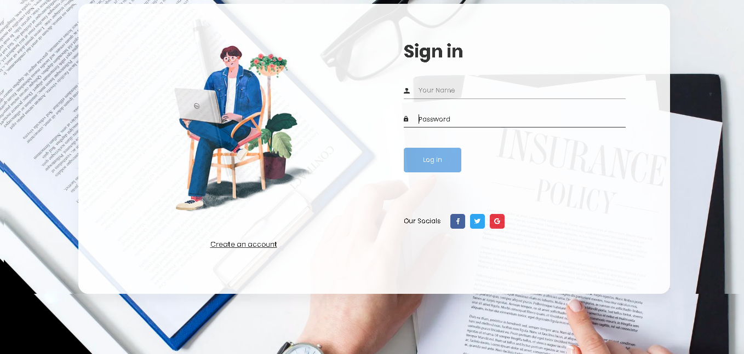

**CUSTOMER:**

**“Section 2: Customer Home Page”**

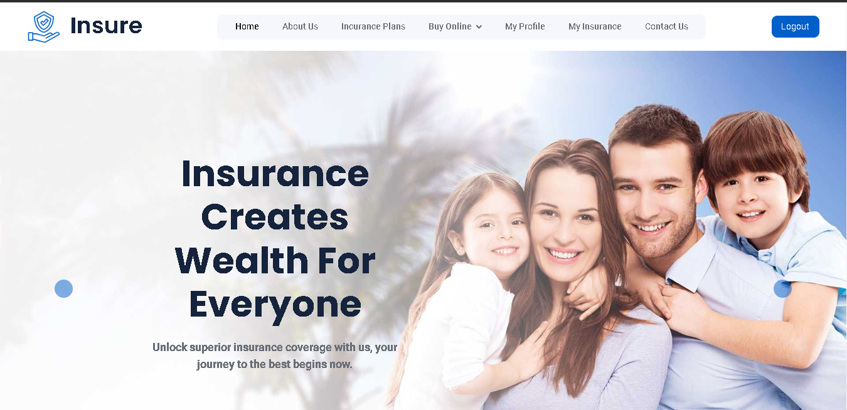



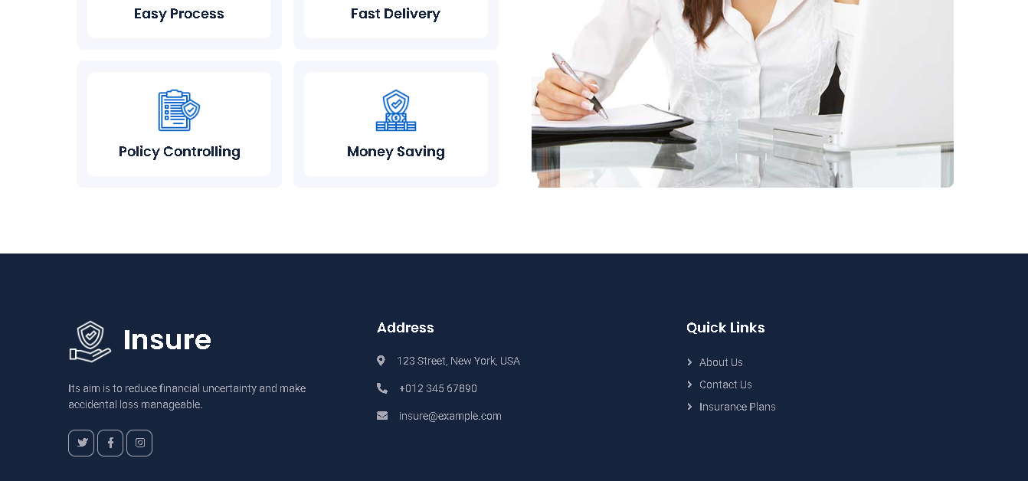

**“Section 3: Insurance Plans”**

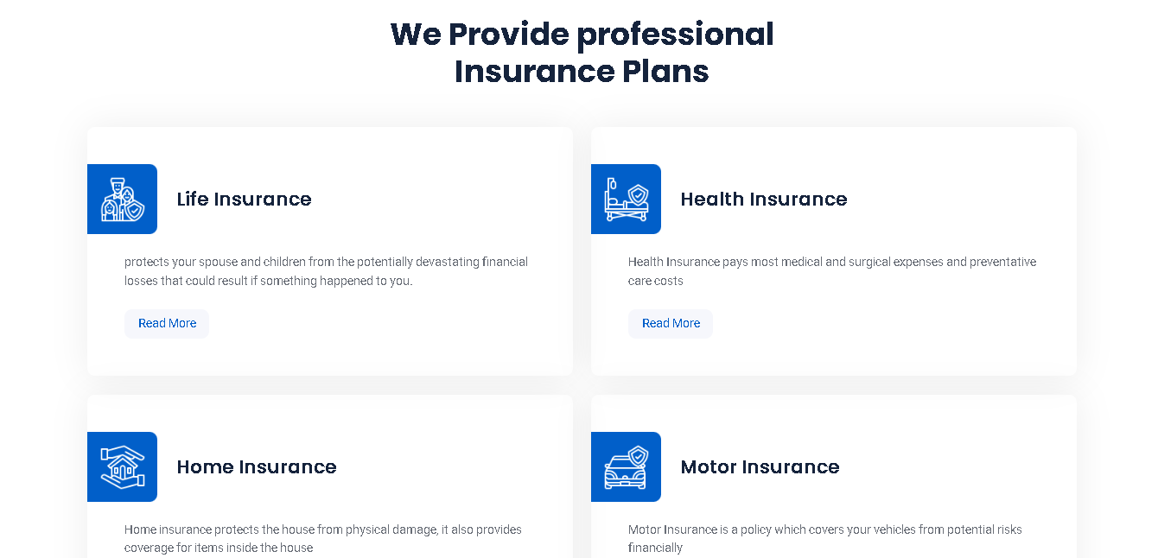

**And after click on read more on every insurance read more button you go to that insurance details page**

**“LIFE INSURANCE DETAILS PAGE”**

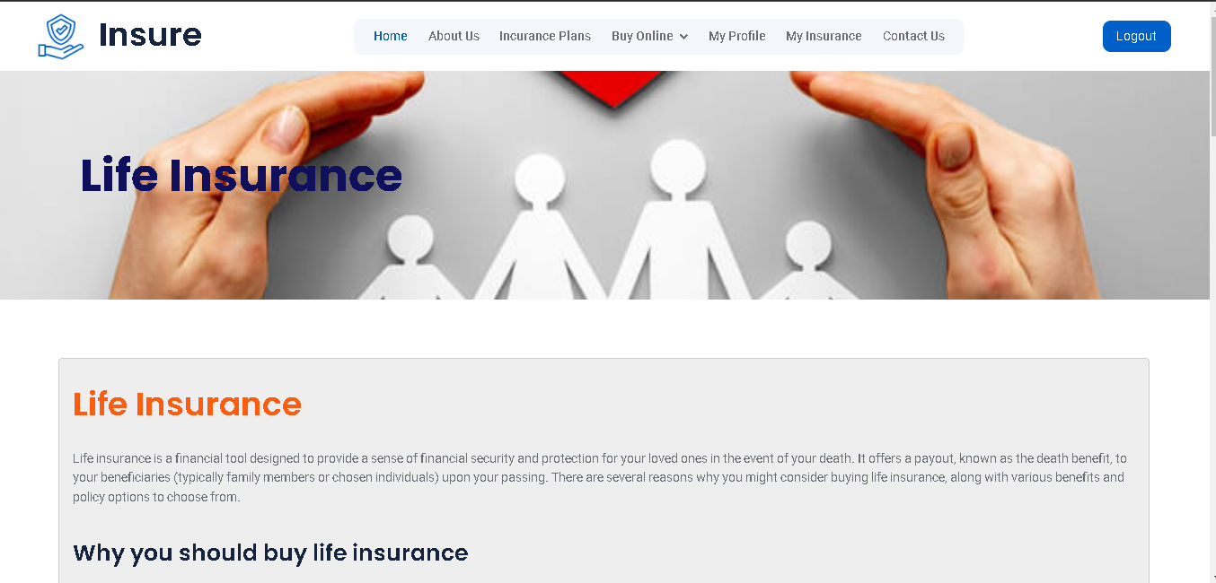

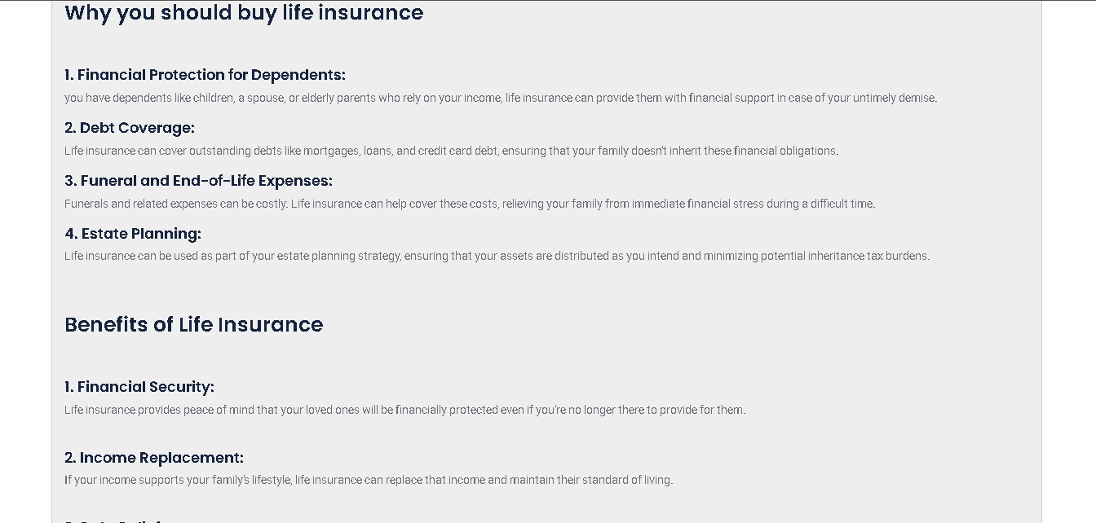

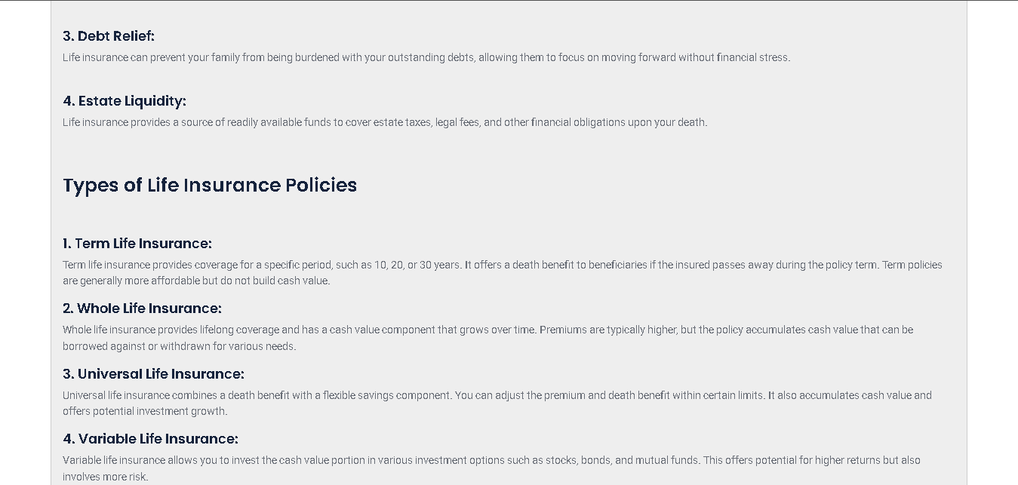

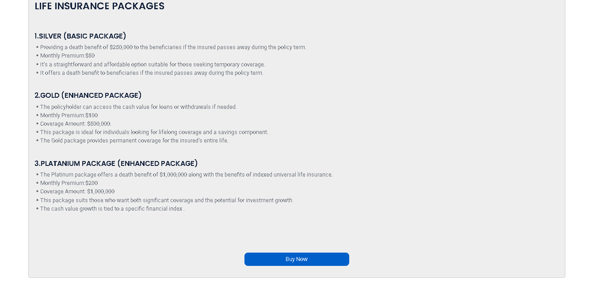

**“HEALTH INSURANCE DETAILS PAGE”**

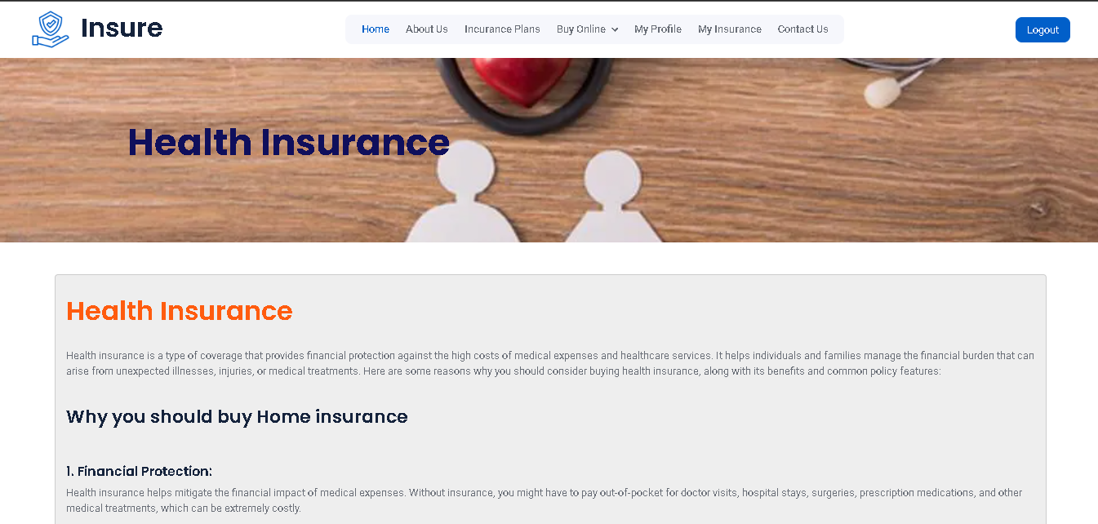

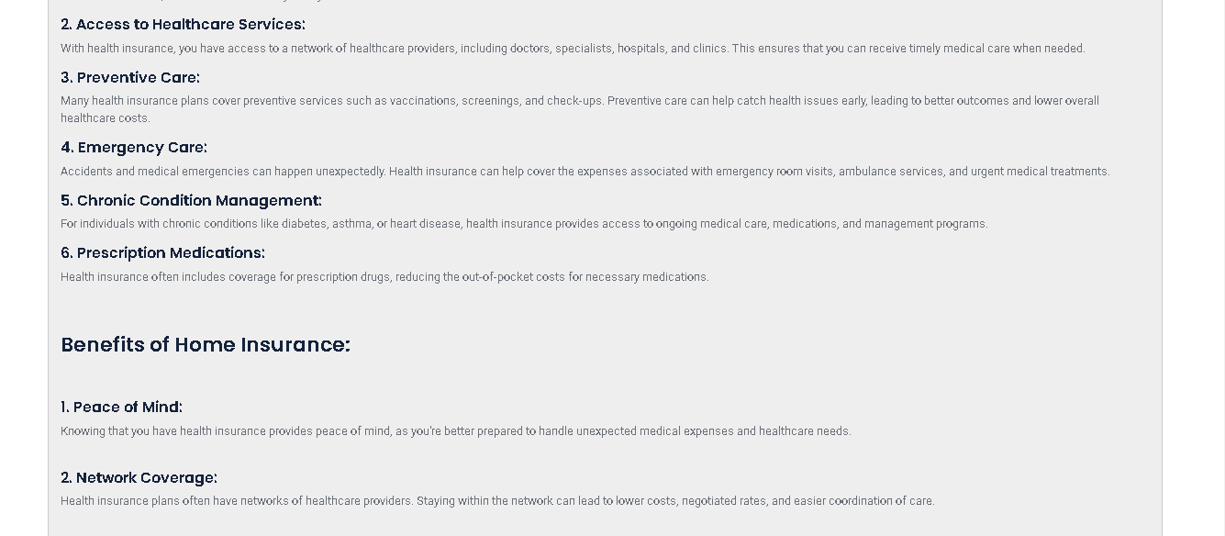

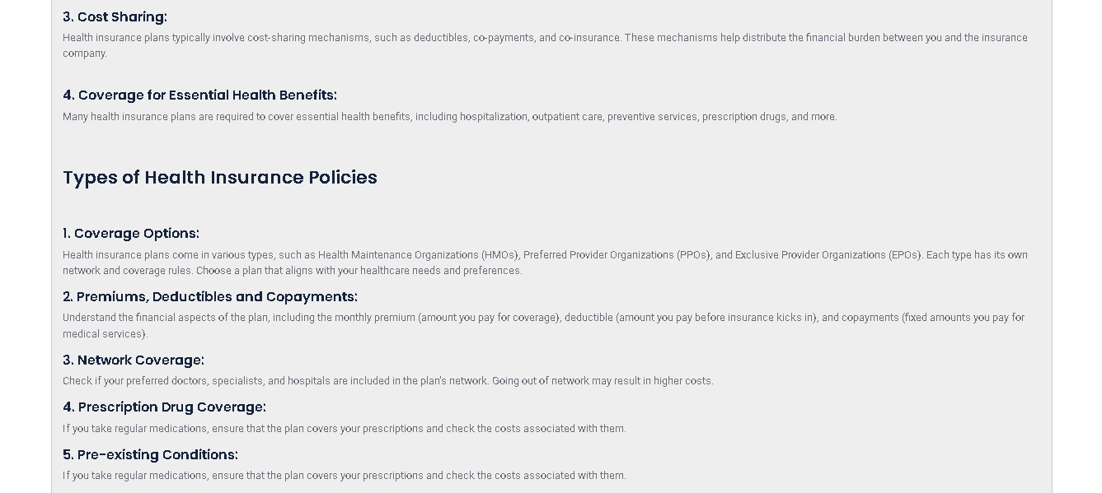

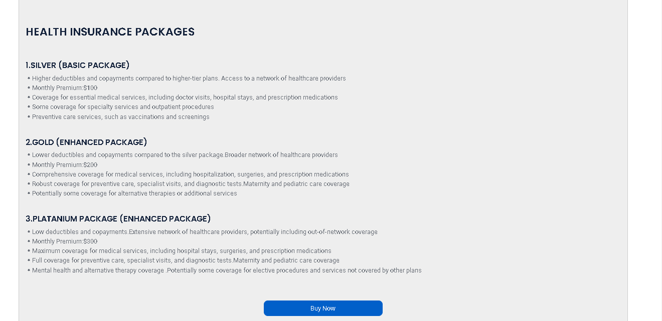

**“HOME INSURANCE DETAILS PAGE”**

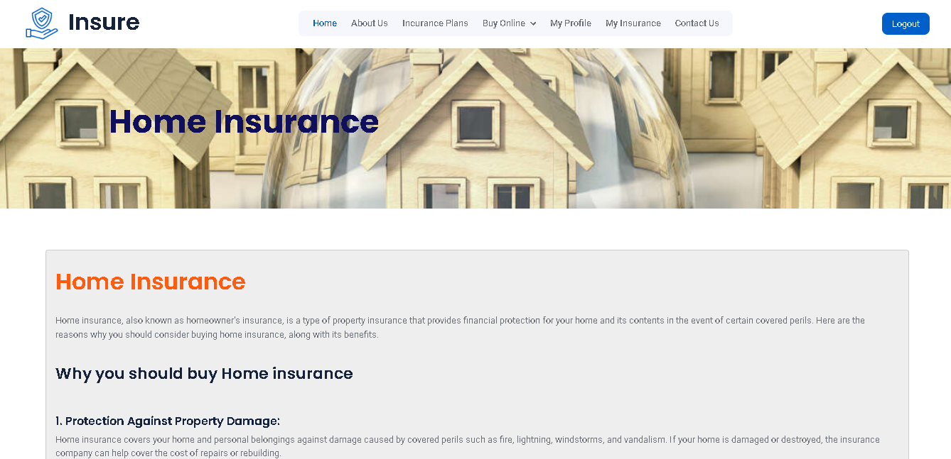

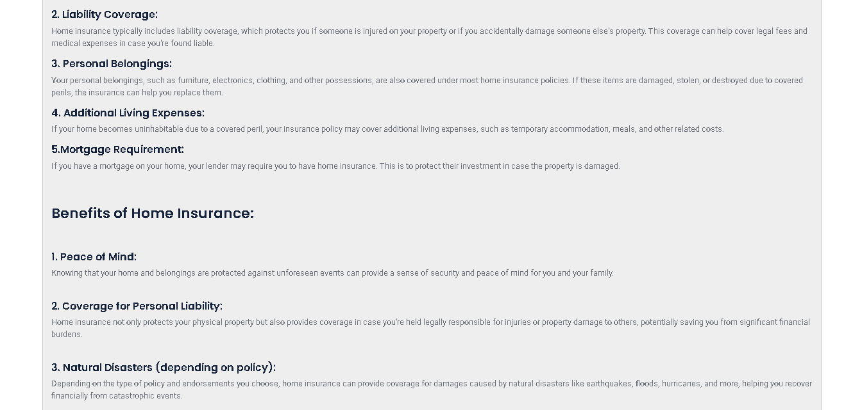

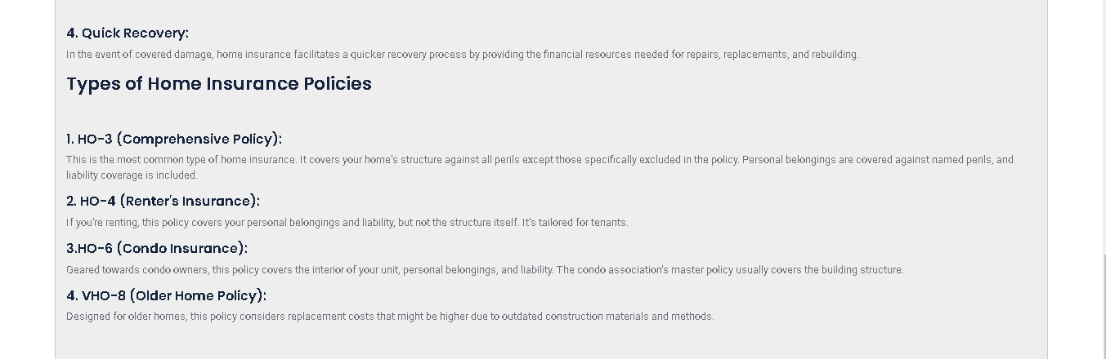

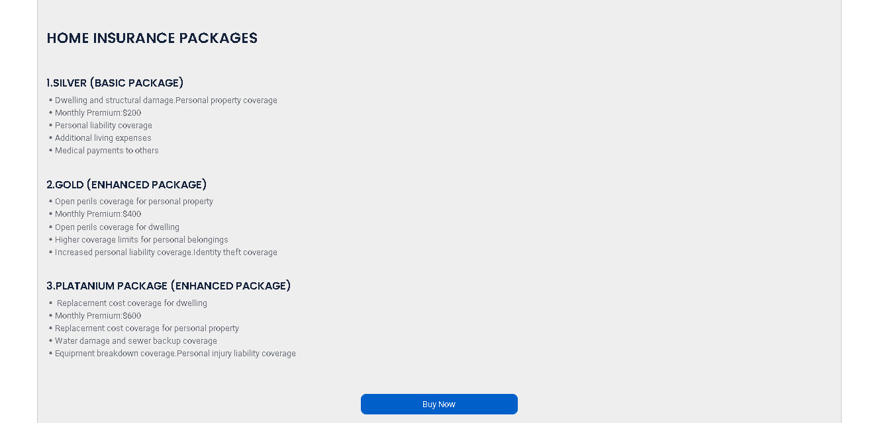

**“MOTOR INSURANCE DETAILS PAGE”**

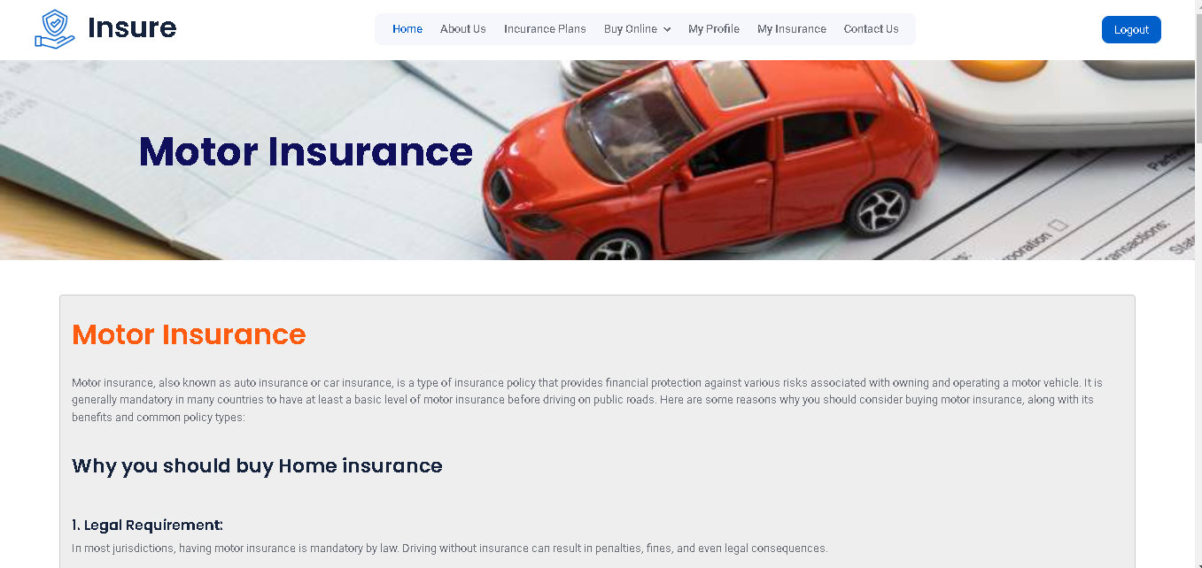

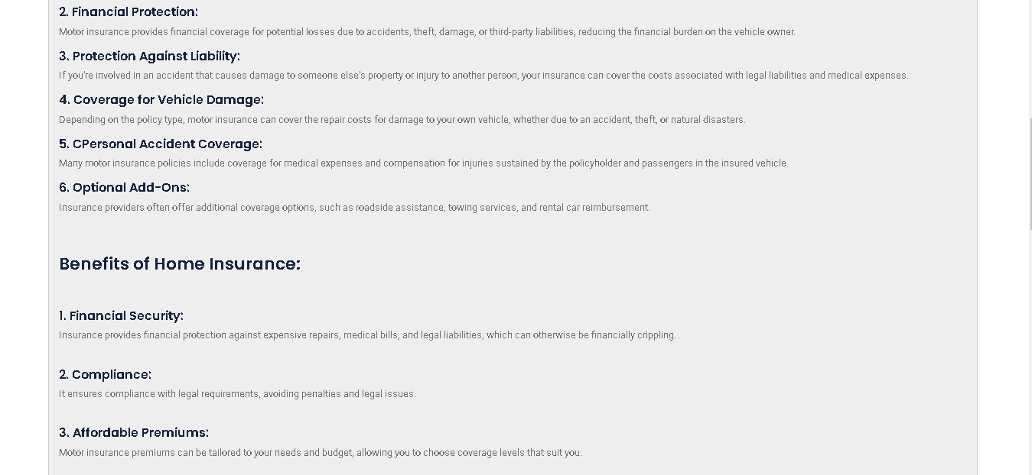

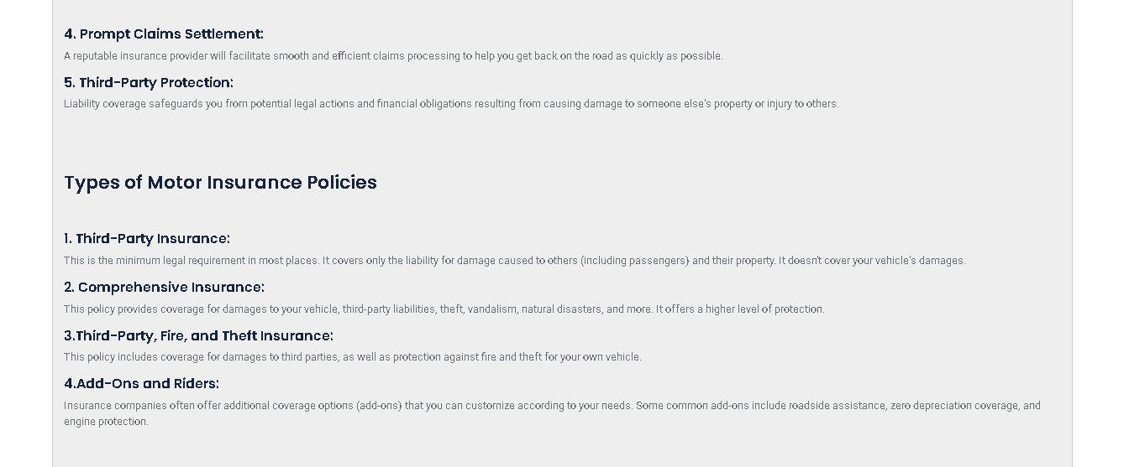

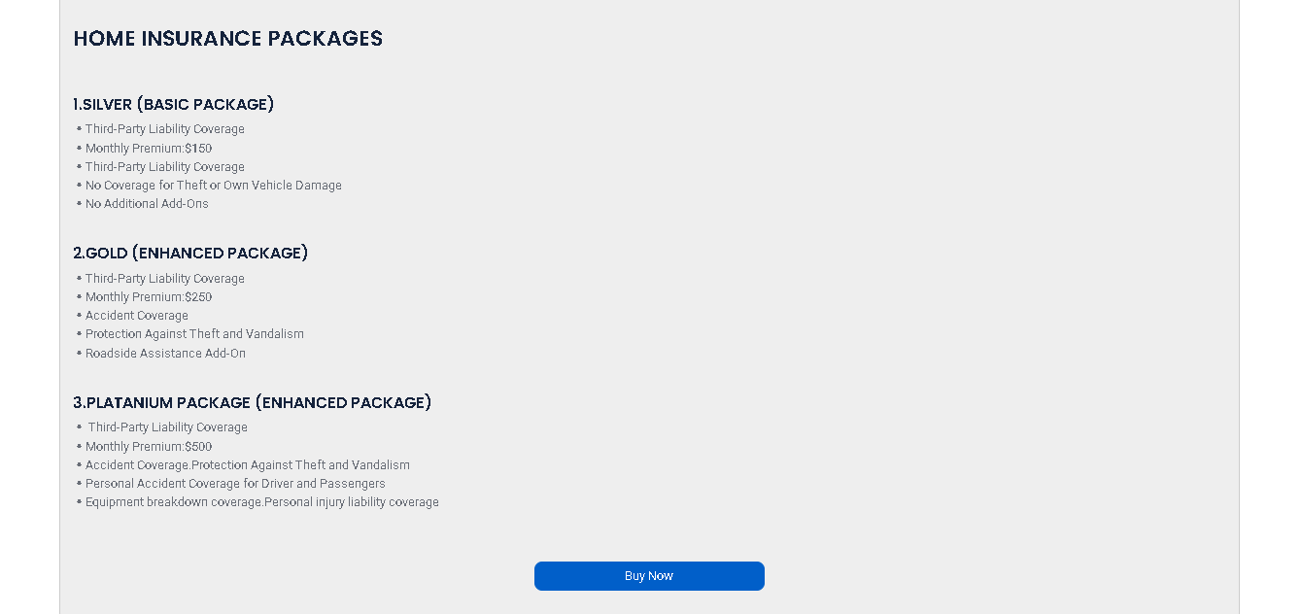

**“Section 4: BUY ONLINE AND ITS HAS INDIVIDUAL INSUARANCE PAGE”**

**“LIFE INSURANCE:”**

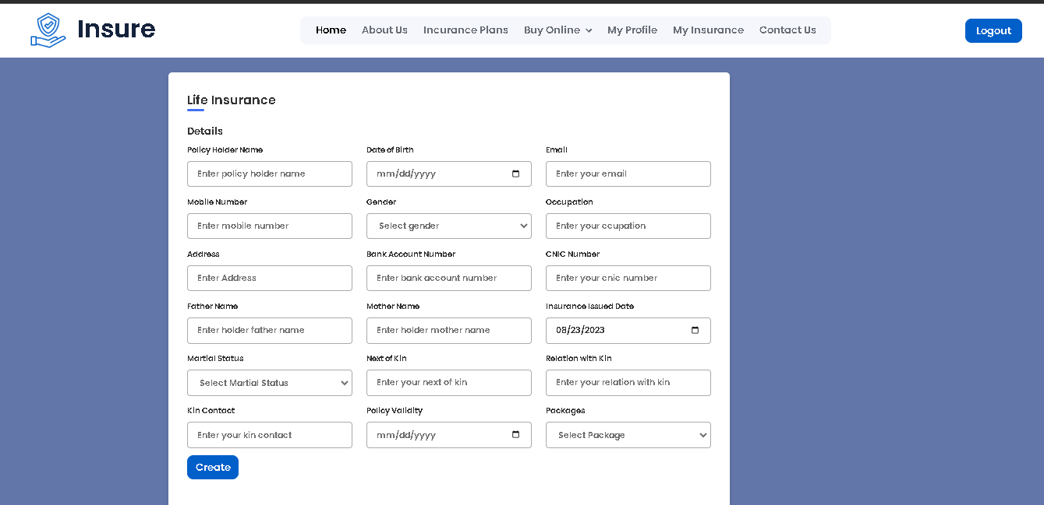

**“HEALTH INSURANCE:”**

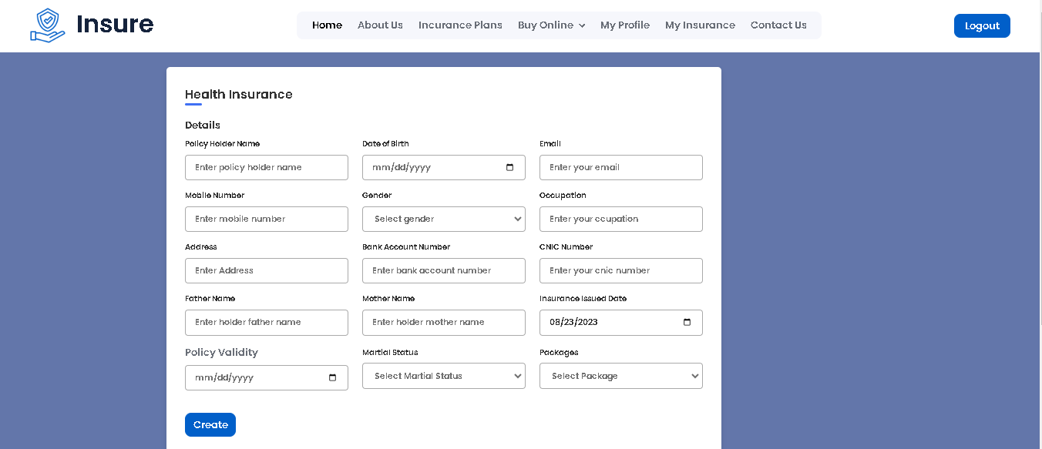

**“HOME INSURANCE:”**

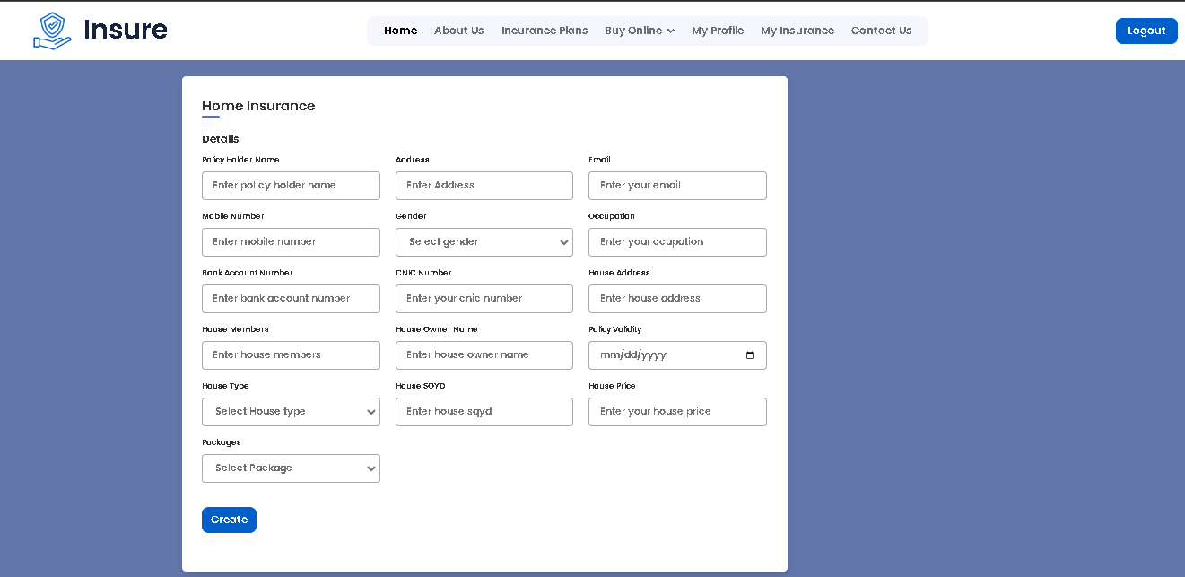

**“MOTOR INSURANCE:”**

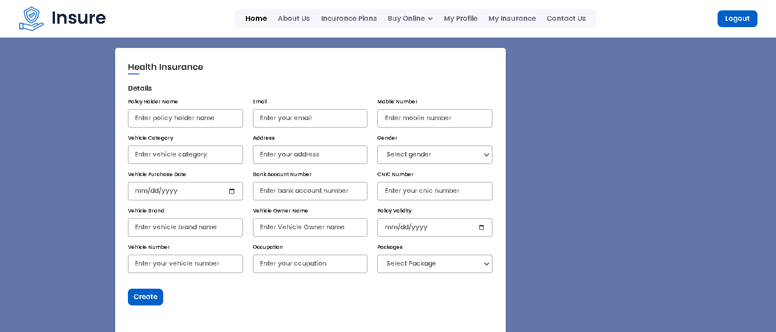

**“Section 4: ABOUT US”**

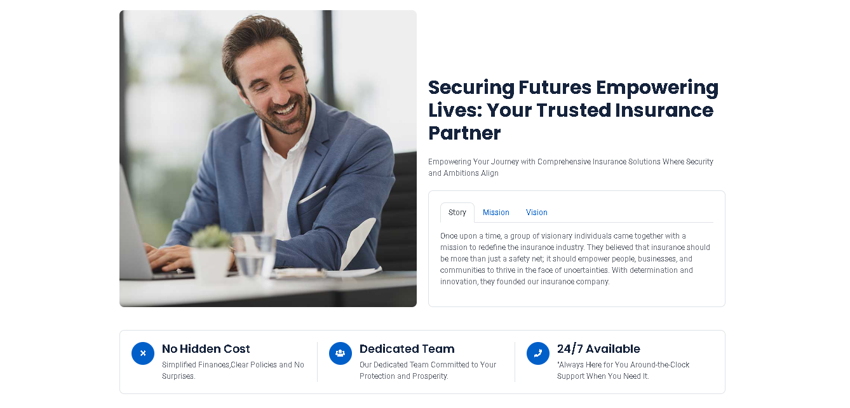

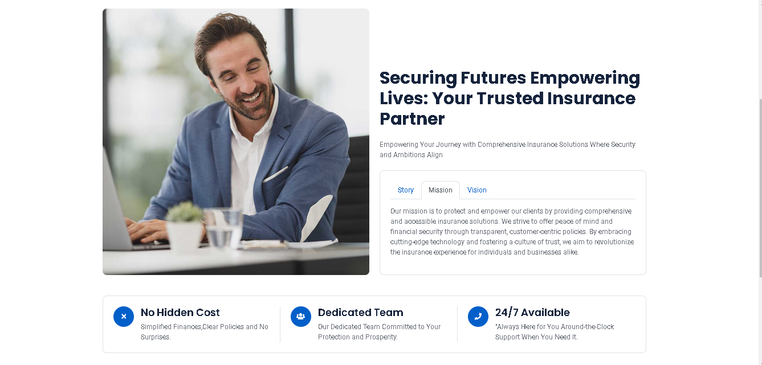

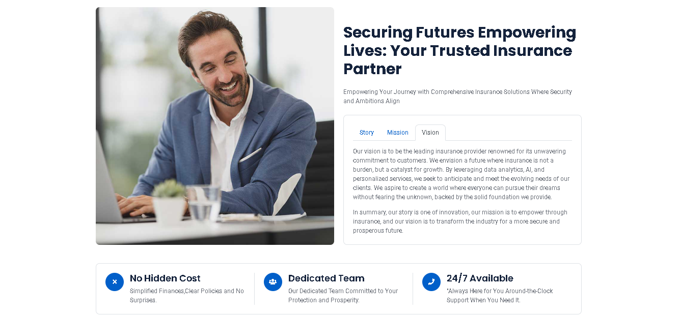

**“Section 5: CONTACT US”**

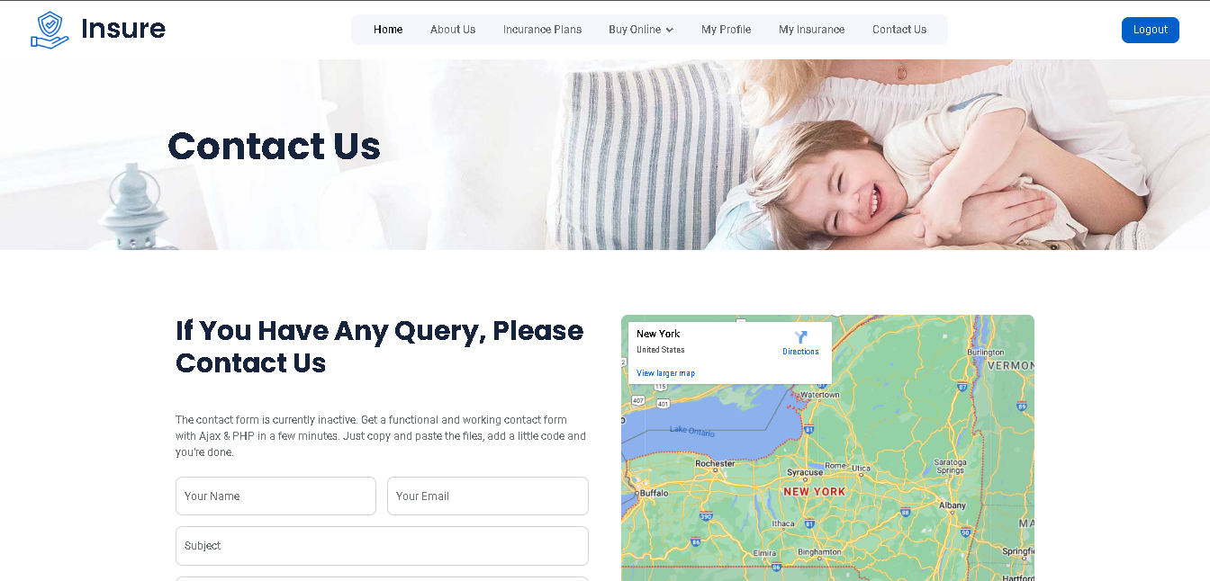

**ADMIN:**

**“Section 6: ADMIN Home Page”**



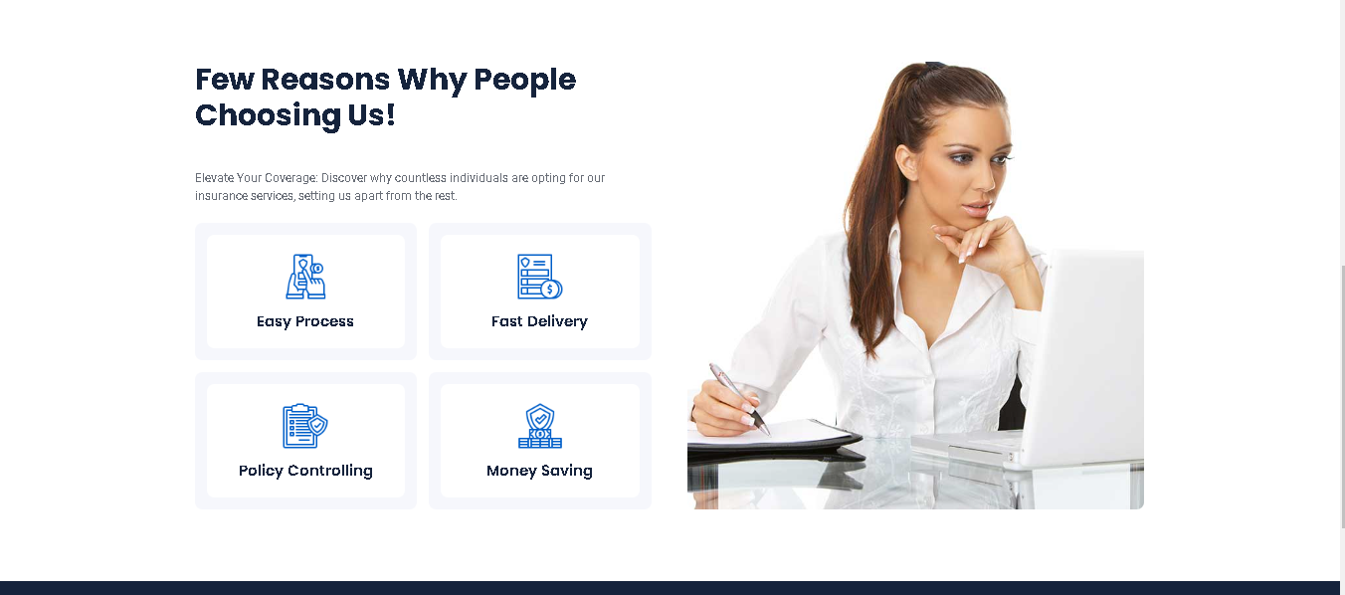

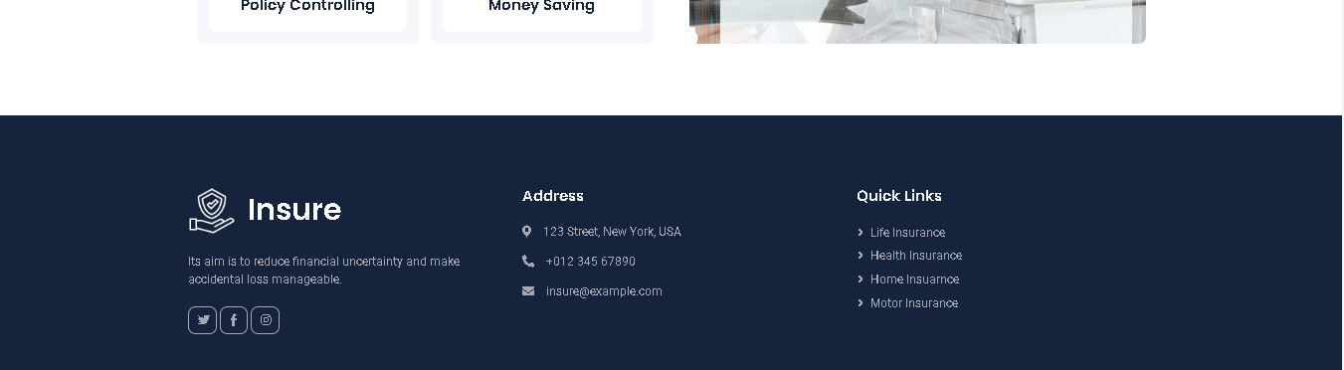

**“Section 7:LIFE INSURANCE ALL DETAILS”**

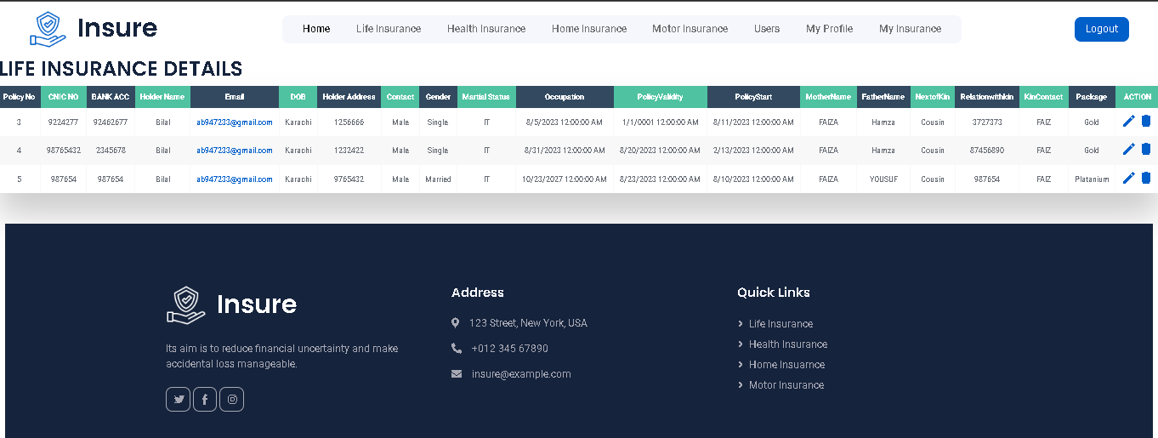

**“IT IS A DUMMY DETAILS”**

**“Section 7.1:LIFE INSURANCE EDIT DETAILS”**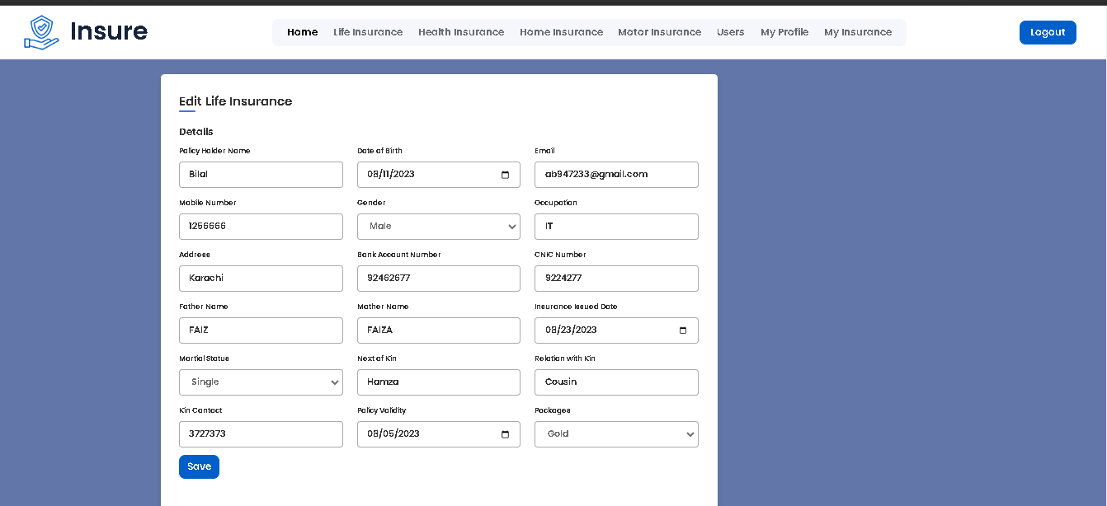

**“Section 8:HEALTH INSURANCE ALL DETAILS”**

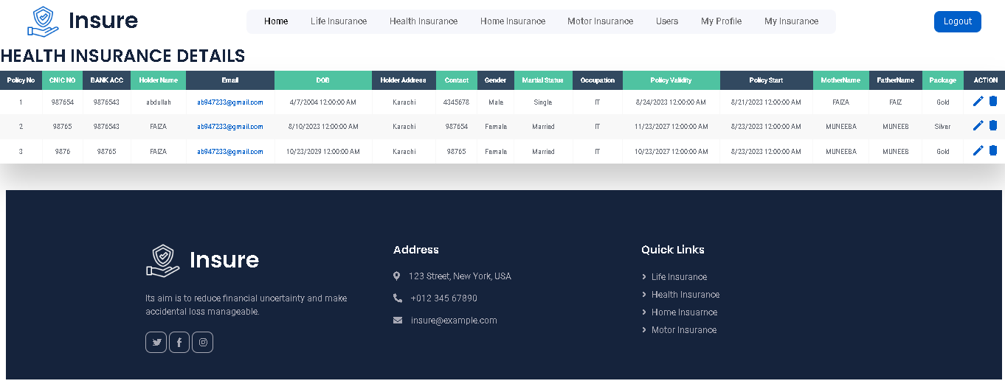

**“IT IS A DUMMY DETAILS”**

**“Section 8.1:HEALTH INSURANCE EDIT DETAILS”**

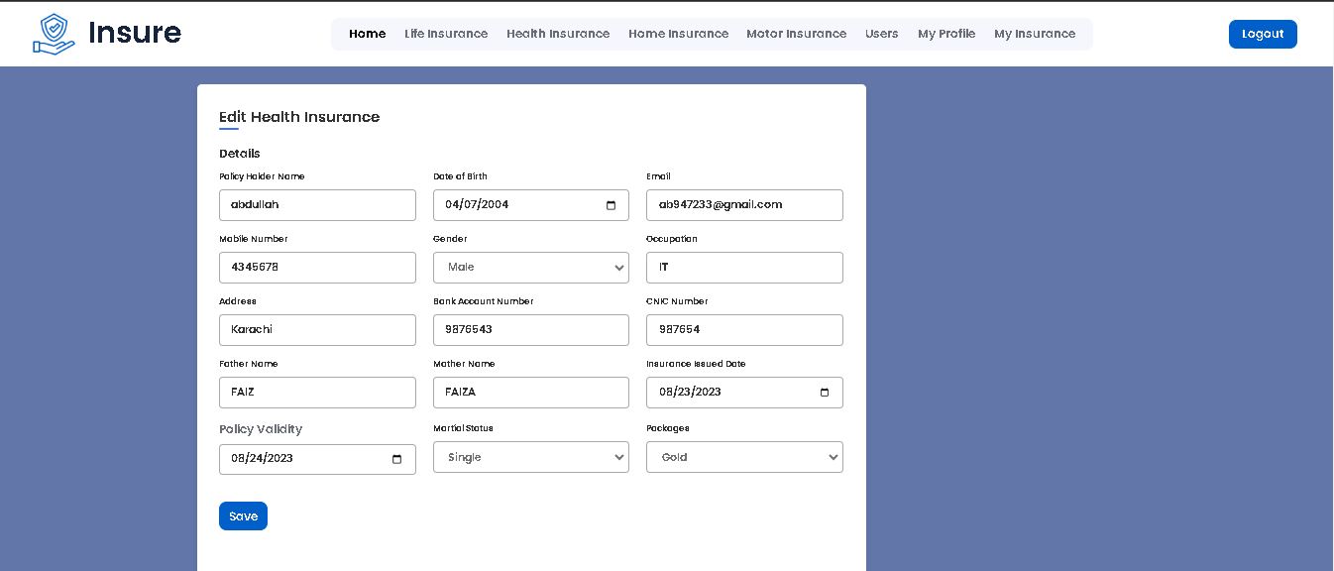

**“Section 9:HOME INSURANCE ALL DETAILS”**

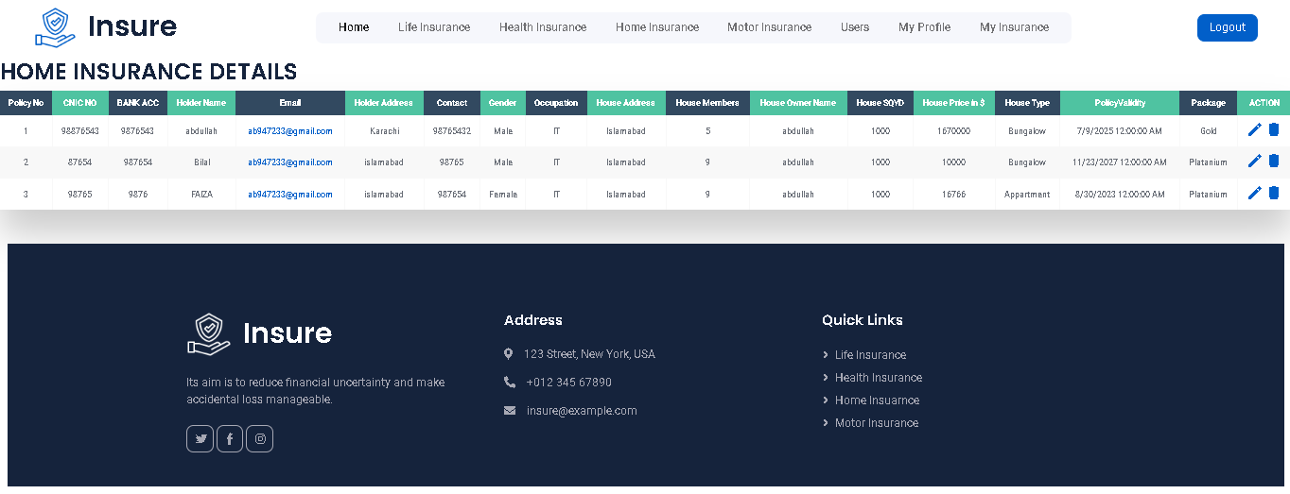

**“IT IS A DUMMY DETAILS”**

**“Section 9.1:HOME INSURANCE EDIT DETAILS”**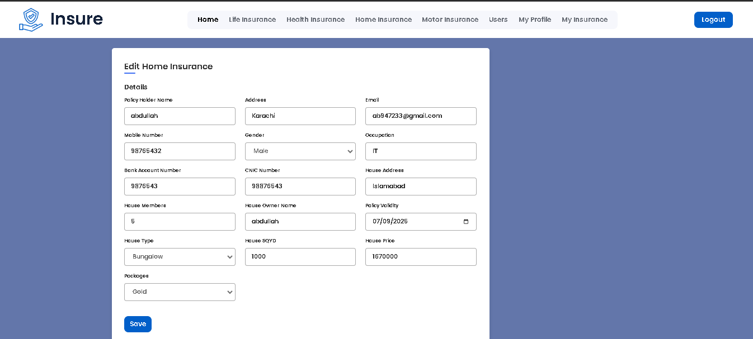

**“Section 10:MOTOR INSURANCE ALL DETAILS”**

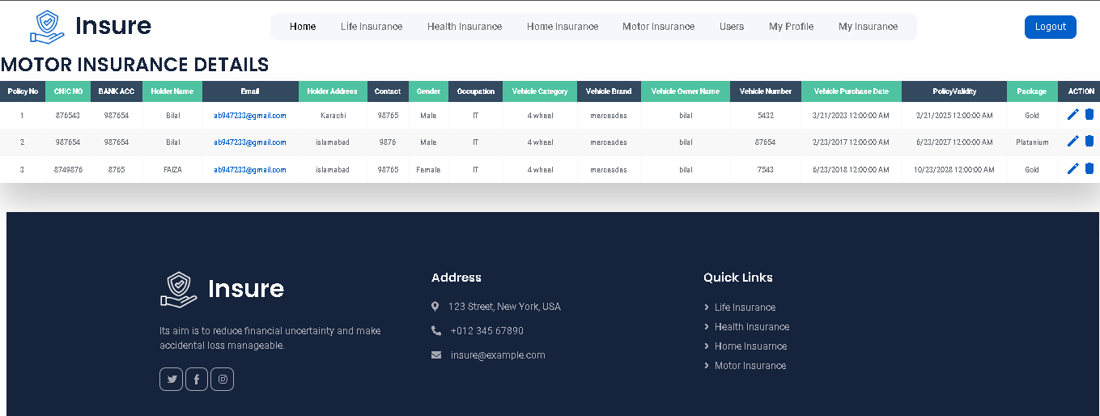

**“IT IS A DUMMY DETAILS”**

**“Section 10.1:MOTOR INSURANCE EDIT DETAILS”**

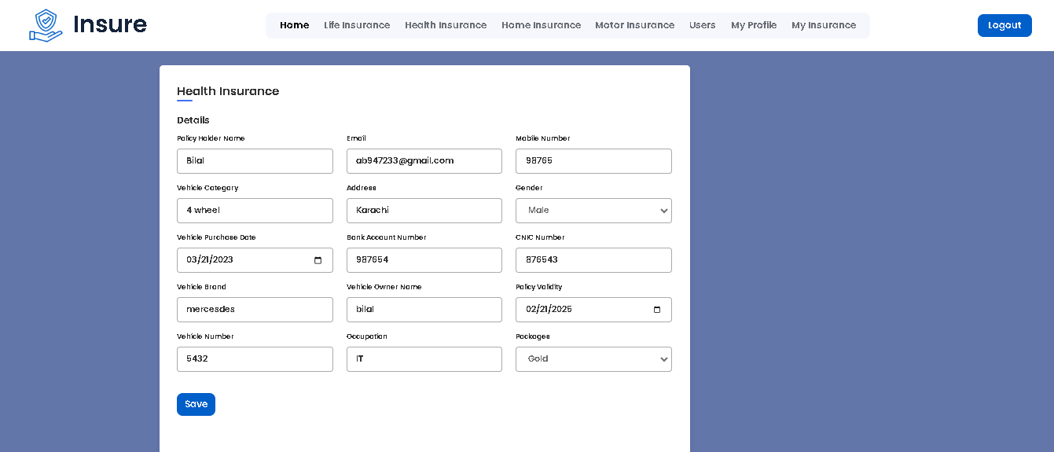

**“Section 10.1:USERS DETAILS”**

